Can the fashion industry ever be sustainable?

Paloma Barroso

Table of Contents

1. **Abstract**
2. **Introduction**
3. **Sustainability**

* Three pillars of sustainability

1. **How are fashion brands implementing sustainability?**

* Patagonia
* Greenwashing

1. **Fast fashion**

* Damages to the environment

1. **Luxury fashion**
2. **Consumer behaviour in the fashion industry**

* Consumers’ habits of purchasing and disposing of clothes

1. **Fashion trend cycle**

* Social media
* microtrends

1. **Slow fashion**

* Advantages of slow production to the environment

1. **Circular economy**

* Regulations for sustainability

1. **Conclusion**
2. **References**

**Appendix 1: Topic mind map**

**Appendix 2: Sources analysis**

**Appendix 3: Survey results**

**Abstract**

As garment production rises, prices for clothing items are decreasing. People wear some shoes for a short period, and the following month, they are not fashionable enough to wear them.

How is this harming our environment? Can fashion ever be a sustainable industry?

In this essay, I will analyse how the fashion industry is determined not to be sustainable by presenting the factors that damage the environment, such as the production process, labour conditions, and changing fashion trends. By doing so, I will discuss whether the fashion industry can achieve sustainability.

**Introduction**

Consumers' need for quantity over quality is pushing our environment to deteriorate more. The fashion industry, being the 7th largest industry in the world, [1] has become increasingly problematic due to the "fast fashion" concept, which encourages the production of large product quantities as quickly and cheaply as possible. This massive production damages the environment and society through water, textile, and energy waste. It creates poor working conditions in the textile manufacturing sector, prioritizing the constant production of clothing according to the newest fashion trends. This creates a cycle of overconsumption for cheap and low-quality clothing.

Fast fashion brands are mainly driven by the excessive consumption of cheap seasonal products; today, the fashion trend cycle moves so quickly that consumers are not able to keep up with the constant changes. As a result, people dispose of clothes when they are no longer wearable, making 85% of the garments produced end up in landfills.[2]

Therefore, the fashion industry already has this established face of being one of the most damaging industries for the environment. With the increasing awareness of sustainability, many CEOS today consider sustainable strategies vital for their businesses to succeed. In contrast, others still opt for non-sustainable procedures such as fast fashion production, generating controversial opinions. Patagonia and Reformation are some of today's most famous sustainable fashion brands. In contrast, Zara and H&M are the top fast fashion brands and the most damaging, that is why I chose to look at them.

My aim is to learn about the role sustainability plays in fashion and in consumer buying behaviour. I will then answer if the fashion industry, including fast fashion and luxury fashion, can be part of a sustainable production cycle.

To answer my question, I will begin by examining the context and relevance of sustainability in the fashion industry, which consists of three main factors: social, environmental, and economic. Consequently, I will analyse the effectiveness of ethical policies implemented globally and see how they impact these three areas of sustainability. I will be investigating the theories that support the fashion industry’s sustainability and compare the production strategies of luxury fashion and fast fashion brands. I will present the results gathered from my primary research, a survey I sent out to 40 people from 16-50 years old and analyse the consumer habits that impact the fashion industry. I will evaluate the potential solutions to reduce the environmental impact of the clothing industry, which are: To reduce damages in the three factors of sustainability by producing less clothing and using ethical materials that are not synthetic fibres. Therefore, companies can charge higher prices for clothing items, and consumers will buy less.

Another solution is a circular economy for textiles, which I will discuss further in this paper. However, it is crucial to evaluate this industry's distribution and manufacturing procedures to determine if they can attain full sustainability considering their social impacts.

**Sustainability**

Cambridge dictionary defines sustainability as ‘the quality of causing no damage to the environment and able to continue for a long time.’ [3]

Connie Ulasewicz[4], a professor of apparel design at San Francisco State University, defines sustainability as a process that does no harm to people or the planet and enhances the well-being of people interacting with any industry.

Sustainability is split up in three pillars: social, economic, and environmental, and it is achieved when these three aspects are not damaged in any way. In the fashion industry, sustainability requires an approach encompassing the entire production process of clothing items, from design development to packaging and delivery. It should benefit the three pillars of sustainability. The economic pillar involves making good use of materials, to make them last longer as well as showing transparency as a brand. That includes sharing the production process and materials used. The environmental pillar ensures the conservation of resources, creating a lower carbon footprint. The social pillar focuses on the values promoted by this industry: consumption, trend cycles, fair labour and wages. Further in this paper, I will discuss how each pillar of sustainability is affected by the fashion industry.

**How are brands implementing Sustainability?**

Undeniably, we are constantly seeing the promotion of more ethical practices. More green fashion adverts have started to appear since consumers' awareness of the damage the fashion industry creates grows. Campaigns such as clean clothes[5] and the Better Cotton initiative surged, aiming to promote a more sustainable approach to the fashion industry. The Better Cotton initiative makes cotton that requires less oil and ensures that integrated pest management diminishes the use of pesticides, enabling brands a better approach to sustainability. Research made by the Forrest Valley, an organisation promoting innovation on production, shows the increase of queries on google with ‘sustainability’ meaning the awareness of consumers is starting to grow.[6] The research shows that 89% of Italian fashion brands work for sustainable goals, but 53% of brands that invest in sustainability, do it for competition matters within the fashion industry.

Vivienne Westwood was one of the first designers to promote making products last longer and on their website the sustainability section is split up by policies, materials, craftsmanship and policy statements. [7] This brand also took part in the UNECE Traceability and Transparency project for the Cotton Value Chain, assessing its transparency for the responsible use of cotton.

Other brands still focus on increasing profit by selling large clothes amounts produced cheaply, known as fast fashion companies. Fast fashion brands focus on selling cheap seasonal clothing and still, they are responsible for their impact on society and the environment and generating controversial opinions from consumers.[8] But how can these brands achieve full sustainability?

According to the fashion transparency index by Fashion revolution, to determine the level of sustainability of a fashion brand, the factors that need to be evaluated are:

* Transparency
* Materials used on production, including non-toxic chemicals.
* Packaging
* Social obligations: Actions taken to reduce emissions
* Working conditions
* Certifications: documentation from unions (Fair trade or any other)

Big Fashion brands are already focusing on promoting sustainability as a business strategy, they use the life cycle assessment (LCA)[9] which is a method that evaluates the life cycle of their products. I chose to look at Patagonia, considered one of the top sustainable brands based on its LCA. LCA shows the materials they use to produce clothes[10] : 87% of the materials used for production are recycled. They started producing from wool and polyester in 2021 and since then Patagonia got ranked by the Fashion Transparency Index at 60% on their traceability- how they share information about their product production, reaching the top 10 of 250 companies on the FTI[11].

Patagonia has built their environmental reputation by investing in activism, recycling and reusing. As seen on their website, the first thing it shows is a section describing the quality of their products: durable and multifunctional, as well as having a section about activism and their campaigns. Their most famous campaign is:

* “Don’t buy this jacket” (2011):

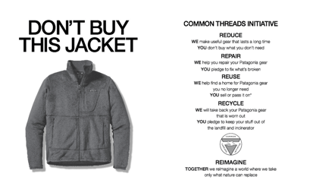It is aimed to encourage conscious consumption; by emphasising that buying less is more ethical. This drew significant attention; It was posted on the New York Times during black Friday, and they were the only the only clothing brand telling people to buy less. Customers accused Patagonia of hypocrisy by addressing the need to consume less, when the company relies on selling. However, Patagonia states that they are just sincere by advertising useful and durable products, making their consumers think twice before they buy. [12]

*Patagonia advertisement from November 25, 2011, edition of The New York Times.*

Patagonia has also launched the programme “worn wear”, in which they used products that people would no longer wear. If all brands would promote responsible shopping and be transparent about their production process, people would only be conscious about what they are consuming; but this does not mean they would completely stop.

As a consumer, we may feel less guilty about consuming fashion in a 'sustainable way', especially when seeing ethical adverts from brands. Therefore, some people chose Patagonia over fast fashion shops. Patagonia has shared impact polypropylene has on the environment, opting for recyclable fabrics since 1993 when they became the first brand to turn soda bottles into polyester, setting a positive example for other brands. Polypropylene is a thermoplastic derived from petroleum, and since it's the most biodegradable compared Polyethylene Terephthalate, it is used for medical items and by clothing manufacturers. This plastic was approved as one of the saftest by the Environmental Protection Agency (EPA). However, recent research I found reliable, has shown polypropylene liberates greenhouse gases and toxic chemicals in the environment. [13]

Another example of a sustainable fashion brand is Tentree. Although they use some animal-derived products, the brand focuses on planting 1 billion trees by 2030, by planting a tree for each item sold.

These brands are leading the way toward a more ethical industry by setting an example of sustainable practices inside fashion brands. Therefore, I believe the fashion industry can attain sustainability by following the example of Patagonia, having a well assessed LCA and using recyclable materials by making consumers conscious.

However, Patagonia is a privately held company, which means they are not obliged to share private information about their product manufacturing. Nonetheless, they still share their clothing products and manufacturing information. Do they truly care about the environment or only seek for profits? Are they greenwashing?

**Green washing**

Greenwashing is the appearance of a brand’s campaign to be more sustainable than it is. It is intended to attract consumers who have purchasing decisions driven by green practices.[14]

Generally, this can be identified when we see advertisements claiming sustainable methods but not providing enough details about what it means for their brand. For example, Patagonia is not 100% sustainable, but they say they are trying to improve this by being more transparent, paying higher wages to workers, and improving product quality by using materials that last longer. Fashion brands can achieve certifications to verify their level of sustainability, and prove they are not greenwashing. Patagonia has been certified by B Corp [15] since 2011 by having a leading social and environmental performance. However, not all brands reach the factors required to be determined a sustainable brand (quality, production, manufacture, or product longevity) which makes them share information about false ethical data. As an example, H&M [16] has been sued for false sustainable marketing, as they said they sell clothes made from old clothes when it is not true, they are massively contributing to the fast fashion industry´s footprint and lying about it. So, fast fashion brands mainly care only about profits, leading to greenwashing.

**The fashion industry and the fast Fashion model impact on sustainability**

Although the fashion industry is already seen as an irrationality in economics (Nystrom suggests "fashion is nothing more than consumption”)[17] it has a crucial role in global economy. It has a value of 1.7 trillion USD today; hence, it is one of the most detrimental industries. According to an analysis by Business Insider, a newspaper that I found to be reliable because of the accurate date, fashion production makes up 10% of carbon emissions. [18]

Over the past 20 years, there has been massive growth in fashion manufacturing, as clothing production doubled between 2000 and 2020 and will keep increasing to 63% by 2030. [19] In the survey I sent out, majority of contestants buy clothes every month (46%) 31% every week and the rest every three months or rarely. Currently, 100 billion garments are produced yearly and end up in landfills. The Atacama Desert in Chile, a giant pile of garments growing by 39000 tons annually is the largest landfill in the world, even visible from space. This goes against the environmental pillar of sustainability, which causes massive waste, and the Chilean government seems to ignore it because it is already too big to be fixed.

Fast Fashion started in the 1990s, when brands aimed to sell large quantities of clothes for the cheapest price, which has powered overconsumption. Consumers feel the need to buy more than what is needed, leading to overproduction of clothing. Fast fashion utilizes the cheapest materials and workers are employed under worst working conditions, employing 1 in every six people in the world which makes it one of the most labour dependant industries. Mainly from low-cost economy countries where labour is cheap to work overtime for example, India, Bangladesh and China. This point proves the fashion industry is not currently satisfying the social pillar of sustainability, so it is not sustainable for society.

So, if this industry generates immense profit, why can't it support all its workers’ and guarantee safe working conditions with proper wages?

Consumers can pressure brands through social media or protest to improve working conditions for employees. "The fair wear foundation," an organisation that started in 1999, aims for better welfare conditions for workers in the garment industry. It supports adequately paid jobs and engages with factories and trade unions to ensure complete pay for workers. This is another solution for material waste, aiming towards more ethical practices inside the social aspect of sustainability.

The biggest fast fashion retailers are Shein, Zara, H&M and Revolve. I chose to look at these brands because I have bought things from there, and I know many people that have too. Inside the economic pillar of sustainability, brands are required to make good use of resources and implement transparency. Shein and Revolve scored less than 10% on the Fashion Transparency Index” (Fashion Transparency Index, 2023)[20] . They do not share the process behind the selling of its products, because even we as consumers, know that their practices don´t fit in any of the sustainable pillars.

The most damaging aspect of these companies is the high-volume clothing production at the lowest prices, making it affordable for people to buy while launching different collections each month. For example, Shein is one of the cheapest brands, it includes promotions, free shipping, and holiday discounts. The prices for a dress start from £8, while the average dress made from cotton needs to be sold for £30 to cover all production costs, from wages to materials. Shein is selling more items for cheaper, using cheap labour and cheap materials that lead to the damage of the social pillar and not respecting fair working conditions. Damaging the social element of sustainability, Shein employees work 75-hour shifts without minimum wage requirements. I found this by watching “Inside The Shein Machine” and noted the workshops people work in are lacking safety guidelines, windows, proper desks and chairs and the workers are sometimes children. The transportation of each Shein item contributes hugely to the CO2 emissions by burning fossil fuels, 2000 items are transported a day on average. These clothes are made In China and must be transported around the world, within a limit of time to satisfy the customer. [21]

Shein is known for its cheap clothing which after a month or so, they become disposable due to the bad quality. Also, being cheap make people not value their shopping, and as a result, they throw them away. One solution for the industry's sustainability could be an increase in pricing to afford producing with higher quality materials so consumers will associate more value with their clothes and, therefore, not dispose of them too quickly and easily. This is called luxury fashion.

**Luxury Fashion**

After the first world war, many fashion brands such as Louis Vuitton and Chanel emerged. These labels focused on quality and in small quantities specially made for someone and by high paid employees having specific skills to produce clothes. But after the growth in consumption, pay for workers has decreased.

People can consider luxury labels to be more ethical and less damaging than fast fashion brands because items are more expensive, and hence, better quality. I carried out primary research which I sent a survey to 40 people to analyse their shopping behaviour in fashion, I asked if they think luxury brands are more sustainable than fast fashion brands, and 77% of contestants said they brands are. I asked one of the contestants why did she think so, and she said because items are more expensive, brands can afford to pay higher wages, better materials and machinery and avoid the cheap production process.

In some part this is true, luxury brands launch less items a year than fast fashion to keep up with exclusivity. Chanel launches six different collections each year, while Shein[22] launches sixteen a year, and Zara more than twenty collections. [23] Furthermore, most of Chanel items are made by silk, fine fabrics, and organic cotton which is more sustainable than normal cotton since it requires less water. Inexpensive materials used by fast fashion retailers are cotton, polyester, which contains microplastics, and most of cheap materials contain phthalates, a toxic chemical for the environment. The use of better materials to produce clothing also creates a longer product life cycle, reducing waste because the quality of these clothes is better. Also, charging higher prices for clothes makes it less affordable, decreasing over consumption.

I analysed the other responses from the survey, and to see how many people prefer to buy quality over quantity of clothes, I asked them if they prefer to buy expensive or cheap garments. Most people answered they prefer to buy expensive with better quality because they last longer. And to see how much money they would spend on clothes that are meant to be better quality, I asked after that how much are they willing to spend in luxury products and 56% of them will buy clothes of more than £100 and 31% will spend under £100. This is implying people have different preferences on shopping habits, but if the majority would buy better quality, they should be willing to spend more, giving more value to their clothes and not disposing them quickly.

Although luxury brands use the better-quality materials, the social pillar of sustainability is not respected by luxury fashion brands. 63% of luxury companies were accused of not paying fair wages to workers; Louis Vuitton pays employees in Italy €2 an hour, without insurance or any proper contracts. So, the environmental impact made by Luxury brands may be lower than fast fashion, but the social damages are still massive. However, luxury does sell quality rather than quantity, which is producing less, but they still don't support the social pillar of sustainability, making the industry not fully sustainable.

Francois Pinault, CEO of Kering (the leading luxury firms), is aiming on balancing profit with purpose on his fashion chains. He has launched a foundation that will transform one million hectares of territory that produces fashion materials called the regenerative fund for nature. [24] They also stated they will give grants to artisans, which might reduce the social impact, but the rest of the big fashion companies need to do this.

After conducting my survey, I realized the influence consumers have on creating a sustainable industry, and this is one factor that is not entirely up to the industry; shopping habits affect the way clothes are consumed, produced and disposed of after use.

**Consumer behaviour in the fashion industry**

Brands stop having control over what people do to their clothes after they are used. When it comes to disposing clothes, out of 38 contestants, 20% still waste them, maybe because they don’t care enough of what happens after. Most people would donate, give to friends and family and others resell or recycle which has lately been easier with applications such as Depop or Vinted. These apps facilitate ethical practices for conscious consumers, by promoting recycling, and most people do it also to get back money on re selling. Even though not all items on Depop are second hand, it encourages users to promote circular fashion and sell garments responsibly, and it is a step towards ethical consumer habits.

I asked people from my primary research what the most considered factors before choosing a brand are.

Style is a key factor in shopping decisions, based on what people like to wear. That suggests most people buy clothes not for necessity, but for style and even as a form of self-expression. Prices are also one of the top decisions people are driven by. If it's cheap, it will attract more customers because items are affordable, which is why fast fashion brands are inclined to charge less, unlike luxury brands. This suggests there is much less demand for expensive brands; although people answered that quality also matters, it doesn't mean quality is sustainable. The chart shows not everyone is a conscious consumer who thinks about the afterlife of garments, 11% of contestants are focusing first on the durability of clothes before buying. It is hard to know the shopping habits of everyone.

Most people are firstly persuaded by affordability and not quality, therefore consumption continues because brands want sales and will continue to launch promotions and coupons, short-term wearable clothing will be produced, sold, and disposed of. Pricing is not the only cause driving mass buying for fashion; it is also the shifts in fashion trends that powers garment waste.

**Fashion trend life cycle**

A 'trend' in fashion, is the changing popularity of a specific item. They are a response to cultural changes or consumers' needs that pushes them to buy certain products at a time.

The fashion industry was the first industry to use this term, to trend forecast and be able to get an insight into what would be consumed over the next time period. After this, brands will start producing and selling the certain “trending” clothes.

When fashion trends are created, they grow to have five stages: The first stage of a trend is 'introduction' where the trend is being introduced into the industry and for the consumers to see. The second stage is 'growth', where people start to purchase the product. In this stage, the trend is becoming to be seen on people and shops. The third stage is 'maturity', when the trend becomes fully established in the fashion market and it has reached its peak of popularity. After an oversaturation of the product, people tend to get tired of it so trends decline.

Brands can’t ignore trends because their sales depend on being fashionable and selling the top items. But what pushes customers to buy trending products?

For a long time, trends came back every 20 years, when the top fashion items of the moment were advertised in magazines or outside ads. Now, with social media, it is easier to reach out to specific customers, so fashion brands have started to advertise through Instagram, TikTok or twitter.

It is easier for designers to get fashion inspiration from digital content since technology updates the fashion trend cycle. People constantly share content of their outfits, ´hauls’ or clothing reviews. On TikTok, fashion trends are promoted every day through influencers and ordinary users. This amount of content every day, gives rise to ´microtrends´, since the algorithm is showing the same videos of a certain style to millions of people. Then, tendencies boost the process of decline for fashion trends within months, because they get too saturated. This overproduction is causing detrimental effects on the environment, leading to a larger waste of material by the quick change in the fashion trend cycle.

In the survey, youngsters (mostly 15-21 years old) are influenced by social media to buy products.

This is another factor suggesting companies and distributors in the industry are not entirely responsible for the environmental damages, and consumers play a big role against sustainable practices with their shopping habits.

As consumers, we can become more responsible when disposing clothes that are no longer `fashionable´, try to resell and recycle, and spending money in fashion brands with certifications such as the GOTS[25] or certified B corporations. (Businesses that meet high standards for social and environmental performance). We can also pressure brands through social media to improve working conditions, "The fair wear foundation” aims for better welfare for workers in the garment industry.

People who buy cheaper clothes will buy more; But there is a contrast between people who are willing to save money and consume cheap quality and people who want to help promote ethical fashion. The impulsive shopping behaviour drives the fashion industry, and makes it hard to evolve towards sustainability.

**Slow fashion**

Without the help from consumers, sustainability can´t be achieved in fashion (argument that leads to my conclusion), however, the opposite of fast fashion is slow fashion, which entails reducing production and consumption. This is a movement and concept that emerged after the slow food movement, encouraging consumers to buy second-hand clothes while buying less often. All consumers should act upon this concept and treat clothes differently and not as disposable as fast fashion.

**Circular economy**

Slow fashion can achieve a circular economy which is when clothes are used more because people give them more value. Generally, people give more value to expensive clothes, and they are less likely to be thrown away within months, but if we start to see clothes more valuable, we can stop disposing of them constantly.

During the Paris Agreement in 2015, the Sustainable Development Goals (“SDG’s”) and the sustainable agenda for 2030 were adopted between the United Nations and 195 countries. These reflect that a change is needed and a different trajectory for sustainability, meaning people are recognizing a change needs to be made.

Countries like Peru and Bolivia are restricting the imports of low-quality textiles, which is efficient because companies in these countries will stop the production of low-quality clothes and therefore, they will last longer. [26] Also, the EU has banned the destruction of unsold textiles, forcing companies to recycle.[27] On one hand, this is effective because companies will be reducing waste and increases transparency. However, it is not as effective since this law can’t control what customers do with their clothes after they have worn them. No brand can track is people dispose or recycle clothes after being worn. The EU's circular economy plans prioritize sustainability, will encourage sustainable business models.

**Conclusion**

The fashion industry is not sustainable at the moment. The damages towards the three pillars of sustainability can be diminished, but not totally zero, due to consumers' habits.

Implementing organic cotton, bamboo linen, and other ethical materials can improve the environmental pillar of sustainability. Also, reducing carbon footprint by selling better quality products. To contribute to the social pillar, companies should be forced by legislation to pay fair wages to all employees (such as the Fabric Act in the US). For the economic factor of sustainability, the industry must provide transparency inside the supply chain, minimise water consumption, and work towards a slow fashion chain by encouraging consumers to

waste less. After looking at Patagonia, I noted it is an example of a brand that has encouraged consumers to buy less by selling good quality products, advertising used-wear, and asking consumers to think twice before buying. Every brand aspires to grow because it is impossible for the industry to survive without sales, but that is why they should produce with organic materials. The fashion industry doesn't have complete control over the achievement of sustainability. It depends on consumers purchasing habits and the value people give to the clothes they buy. Even if brands are sustainable with full certifications, consumers still must change the way they dispose of their clothes because companies are not responsible for what people do with their clothes after they are worn. I have noted this in my primary research while conducting a survey and analysed how people react to fashion and realised the significant impact customers have, too.

Depop and vinted have made recycling easier, encouraging people to buy and sell second-hand clothes, which makes people dispose of clothes more ethically. If people give clothes more value, are more mindful of what they purchase, and the industry strategizes towards the three sustainable factors, sustainability can be achieved.

**References**

* *Overconsumption in the fashion industry* (no date) *Overconsumption in the fashion industry: Fashion Revolution*. Available at: https://www.fashionrevolution.org/overconsumption-in-the-fashion-industry/ (Accessed: 20 July 2023).
* *Sustainability* (no date) *United Nations*. (Accessed: 05 July 2023) Available at: <https://www.un.org/en/academic-impact/sustainability#:~:text=In%201987%2C%20the%20United%20Nations,development%20needs%2C%20but%20with%20the>
* Simon (2023) *What is sustainability in fashion?* *Sustainability Success*. Available at: https://sustainability-success.com/what-is-sustainability-in-fashion/ (Accessed: 01 August 2023).
* *Defining ‘better’: Our principles and criteria* (2023) *Better Cotton*. Available at: <https://bettercotton.org/what-we-do/defining-better-our-standard> (Accessed: 15 September 2023).
* Our Editors. (2023, June 28).
* *35 Sustainable Clothing Brands Betting Against Fast Fashion - The Good Trade*. The Good Trade. <https://www.thegoodtrade.com/features/fair-trade-clothing/>
* Saha, N. (2023). What is Fast Fashion? Why is it Bad? *Your Sustainable Guide*. <https://yoursustainableguide.com/what-is-fast-fashion/>
* *value fashion industry 2023 - Google Search*. (n.d.). <https://www.google.com/search?q=value+fashion+industry+2023&oq=value+fashion+industry+2023&aqs=chrome.0.69i59.2159j0j7&sourceid=chrome&ie=UTF-8&safe=active&ssui=on>.
* Admin. (2022, November 7). *Fast Fashion Waste Is Choking Developing Countries With Mountains of Trash*. ICMGLT. <https://icmglt.org/fast-fashion-waste-is-choking-developing-countries-with-mountains-of-trash/>
* Team, R. (2020, September 11). *7 Organisations working to improve labour conditions in fashion amid the COVID-19 crisis - RCGD Global*. RCGD Global. <https://www.rcgdglobal.com/2020/04/17/7-ngos-working-to-improve-labour-conditions-in-fashion-amid-the-covid-19-crisis/>
* Ltd, S. S. (2022, September 21). *Social Media Marketing for Fashion Brands: A Strategy That Works (with Examples)*. The Social Shepherd. <https://thesocialshepherd.com/blog/social-media-strategy-fashion-brands>
* Kamprad, D. (2023) How sustainable is Patagonia? all you need to know, Impactful Ninja. Available at: https://impactful.ninja/how-sustainable-is-patagonia/ (Accessed: 02 August 2023).
* TBH, T. (2023) *Marketing strategies and brand campaigns of Patagonia*, *The Brand Hopper*. Available at: https://thebrandhopper.com/2023/06/20/marketing-strategies-and-brand-campaigns-of-patagonia/ (Accessed: 11 august 2023).
* Howland, D. (2017) *Report: ‘ultra-fast’ fashion players gain on Zara, H&M*, *Retail Dive*. Available at: https://www.retaildive.com/news/report-ultra-fast-fashion-players-gain-on-zara-hm/443250/ (Accessed: 02 November 2023).
* *What is Sustainable Luxury Fashion in 2023?* (2019) *The Classic T-Shirt Company*. Available at:https://theclassictshirt.com/blogs/stories/sustainable-luxury-fashion (Accessed: 06 November 2023).
* Sophie Caldott (2023) *Are Luxury Brands more sustainable?* *Remake*. Available at: https://remake.world/stories/areluxury-brands-more-sustainable/ (Accessed: 06 November 2023).
* Howland, D. (2017) *Report: ‘ultra-fast’ fashion players gain on Zara, H&M*, *Retail Dive*. Available at: https://www.retaildive.com/news/report-ultra-fast-fashion-players-gain-on-zara-hm/443250/ (Accessed: 06 November 2023).
* ANNA MIKHAYLYANTS (March 9,2023) *Tiktok Core: The Fashion World of today: Arts: The Harvard Crimson*, *Arts | The Harvard Crimson*. Available at: https://www.thecrimson.com/article/2023/3/9/tiktok-aesthetics-microtrends-fast-fashion-style/#:~:text=Microtrends%20are%20fashion%20fads%20that,falling%20off%20just%20as%20quickly. (Accessed: 06 September 2023).
* Research guides: Fashion industry: A resource guide: Introduction (no date) Introduction - Fashion Industry: A Resource Guide - Research Guides at Library of Congress. Available at:https://guides.loc.gov/fashion-industry (Accessed: 07 November 2023).
* Koszewska, M. (2019) ‘Circular economy in textiles and fashion—the role of a consumer’, Circular Economy in Textiles and Apparel, pp. 183–206. doi:10.1016/b978-0-08-102630-4.00009-1.

**Appendix 1: topic mind map**

How I concluded my essay sections, this is how they all link together.

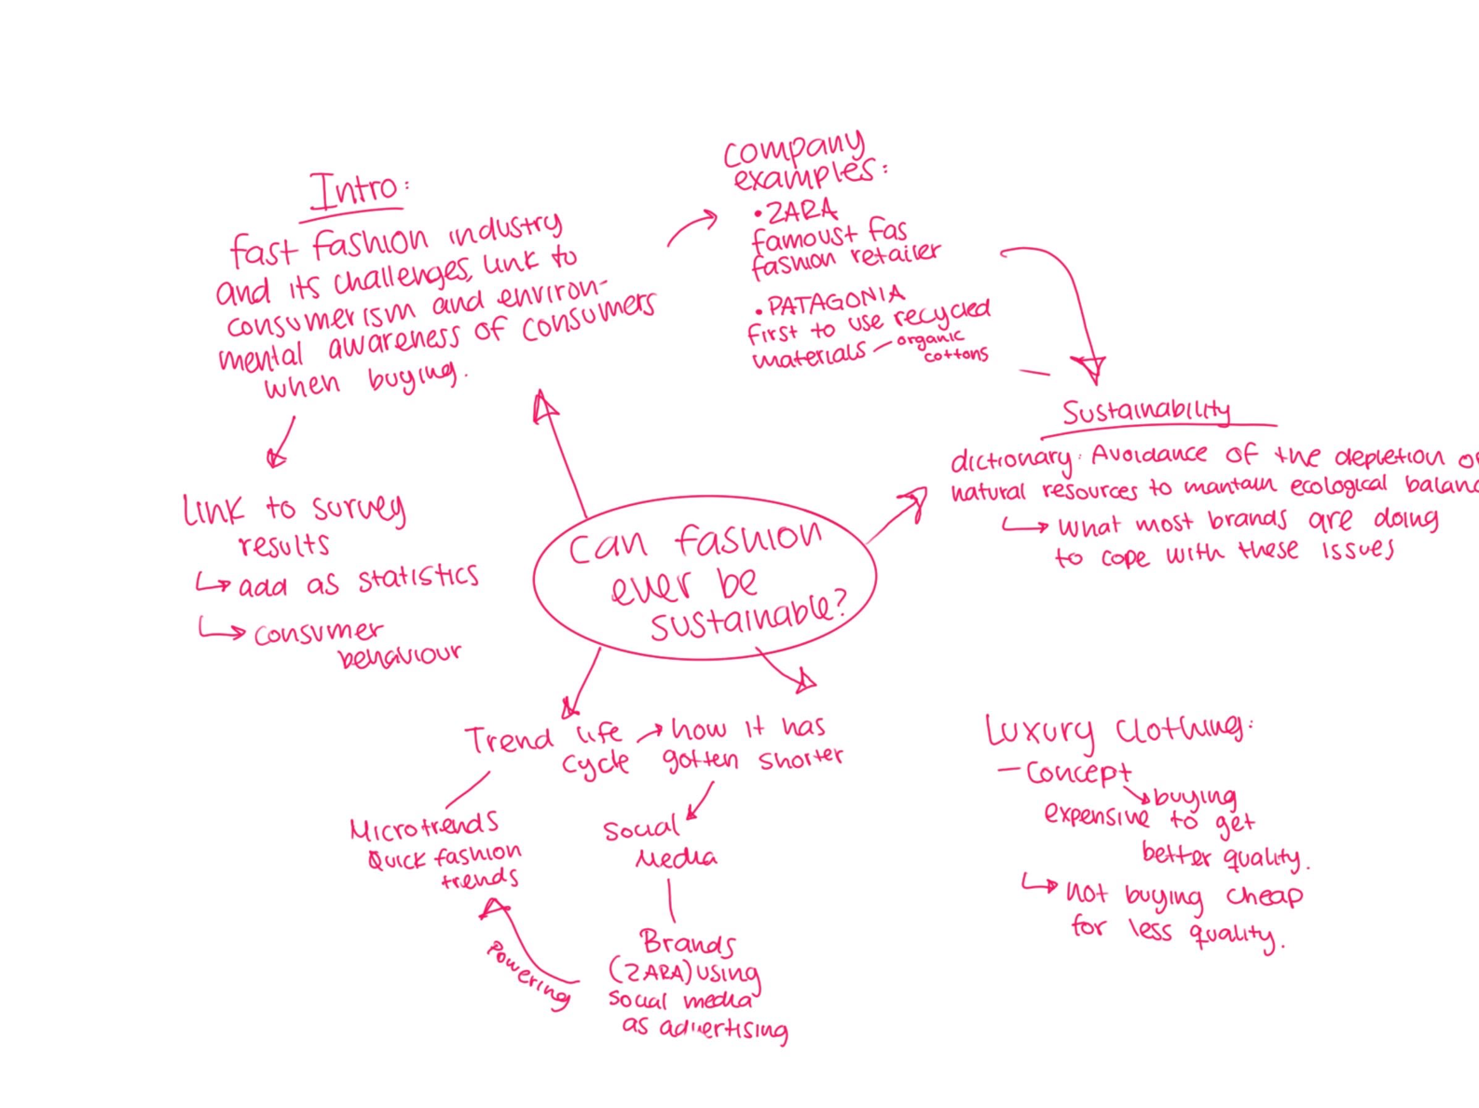

**Appendix 2: source analysis**

This will be added to my printed product log

**Appendix 3: primary research survey results**

To analyse the shopping habits that people have in fashion, I included these questions mostly to see how often people buy clothes, how they dispose of them and to see if they are aware enough of sustainability in fashion. I sent out the survey to 40 people I know, most aged from 15 to 40 years old. I didn’t end up including all of the questions in my report since I only showed the most important ones for my research.

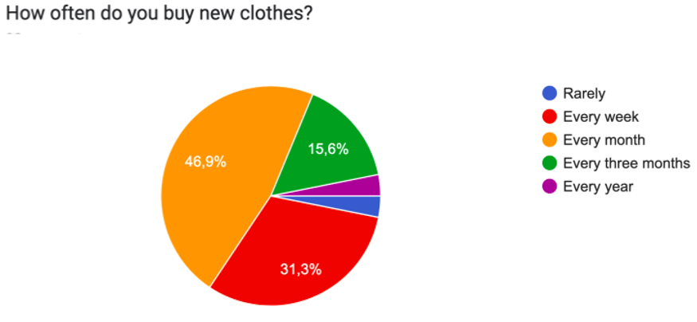

1. (No date) *The state of fashion 2017 - mckinsey & company*. Available at: https://www.mckinsey.com/~/media/McKinsey/Industries/Retail/Our%20Insights/The%20state%20of%20fashion/The-state-of-fashion-2017-McK-BoF-report.pdf (Accessed: 30 May 2023).
2. *Overconsumption in the fashion industry* (no date) *Overconsumption in the fashion industry : Fashion Revolution*. Available at: https://www.fashionrevolution.org/overconsumption-in-the-fashion-industry/ (Accessed: 20 July 2023).
3. *Sustainability* (no date) *Cambridge Dictionary*. Available at: https://dictionary.cambridge.org/dictionary/english/sustainability (Accessed: 14 august 2023).
4. *what is sustainability in the fashion industry?* (2022) *St. Catherine university*. available at: https://www.stkate.edu/newswire/news/sustainability-in-fashion-industry (accessed: 16 September 2023).
5. *Clean clothes campaign*. Clean Clothes Campaign. (2020, August 6). <https://cleanclothes.org/>
6. *fashion and sustainability: awareness and challenges among italian fashion businesses* (no date) *forest valley*. available at: https://www.forestvalley.org/article/sustainability-and-fashion-report-2021?utm_source=linkedin&utm_medium=paid&utm_campaign=startup_awareness&gclid=cjwkcajwgzcobhbneiwaz35rwrkud09ihnbfinuc7mdzhnuitifil2d8s170pwqnsgdfd7jgjsc8abocbh0qavd_BwE (Accessed: 1 August 2023).
7. YouTube. (2021, December 10). *Why fashion brands are doubling down on sustainability | the business of fashion show*. YouTube. <https://www.youtube.com/watch?v=iMyUgoL1mI8>
8. (Hayward et al., 2013)
9. Life cycle assessment. Life Cycle Assessment - an overview | ScienceDirect Topics. (n.d.). <https://www.sciencedirect.com/topics/earth-and-planetary-sciences/life-cycle-assessment>
10. Kamprad, D. (2023, July 19). How sustainable is Patagonia? all you need to know. Impactful Ninja. <https://impactful.ninja/how-sustainable-is-patagonia/#:~:text=Since%2087%25%20of%20Patagonia%20products,Patagonia%20use%20for%20their%20products%3F>
11. Fashion transparency index 2023. FASHION TRANSPARENCY INDEX 2023: Fashion Revolution. (n.d.). <https://www.fashionrevolution.org/about/transparency/>
12. PatagoniaWe’re in business to save our home planet. (2023, October 11). Don’t buy this jacket. Patagonia. <https://eu.patagonia.com/gb/en/stories/dont-buy-this-jacket-black-friday-and-the-new-york-times/story-18615.html>
13. Assoune, A. (2021, March 19). The truth about polypropylene fabric. Panaprium. <https://www.panaprium.com/blogs/i/polypropylene-fabric>
14. What is greenwashing, and how do you spot it?. Business News Daily. (n.d.). <https://www.businessnewsdaily.com/10946-greenwashing.html>
15. Bcorporation.net. (n.d.). <https://www.bcorporation.net/en-us/find-a-b-corp/> accessed 27 September 2023
16. Sierra, B. (2022, September 8). H&M is Being Sued For “Misleading” Sustainability Marketing. — The Sustainable Fashion Forum. The Sustainable Fashion Forum. <https://www.thesustainablefashionforum.com/pages/hm-is-being-sued-for-misleading-sustainability-marketing-what-does-this-mean-for-the-future-of-greenwashing#:~:text=On%20the%20heels%20of%20the,sustainable%20nature%20of%20their%20products>
17. Nystrom (1928)
18. International, B. I. (n.d.). *Our addiction to quick, cheap fashion is adding 101 million tons to landfills each year - and the holidays are only going to make it worse: Business insider méxico: Noticias Pensadas para Ti*. Business Insider México | Noticias pensadas para ti. <https://businessinsider.mx/fast-fashion-christmas-shopping-clothes-returns-shein-zara-waste-mountain-2022-12/?r=US&IR=>
19. Saskia Manshoven, S. (no date) *ETC/WMGE report 6/2019: Textiles and the environment in a circular economy*, *Eionet Portal*. Available at: https://www.eionet.europa.eu/etcs/etc-wmge/products/etc-wmge-reports/textiles-and-the-environment-in-a-circular-economy (Accessed: 10 July 2023).
20. *14 Hard Fast Fashion Facts and Statistics*. Good On You. (2023, August 10). <https://goodonyou.eco/fast-fashion-facts/>
21. *Shein clothing - design life*. Cycle. (n.d.). <http://www.designlife-cycle.com/shein-clothing#:~:text=Shein%20clothing%20materials%20are%20also,if%20released%20into%20the%20environment>
22. Dear pursebop. PurseBop. (2023, September 12). <https://www.pursebop.com/dearpursebop/question/what-are-the-6-chanel-collections-and-the-time-of-year-they-are-released>
23. Howland, D. (2017, May 22). Report: “ultra-fast” fashion players gain on Zara, H&M. Retail Dive. <https://www.retaildive.com/news/report-ultra-fast-fashion-players-gain-on-zara-hm/443250/#:~:text=H%26M%20releases%2016%20collections%20each,faster%20production%20and%20delivery%20times>
24. Pidgeon, E. (2021, June 15). *How François-Henri Pinault is leading Kering’s future of Sustainable Fashion*. The CEO Magazine. <https://www.theceomagazine.com/business/coverstory/kering-francois-henri-pinault/>
25. Home - gots. Home - GOTS. (n.d.). <https://global-standard.org/>
26. Ocasio, B.P. (no date) *Remember Chile’s infamous clothing dump? this is what it looks like now*, *Remember Chile’s Infamous Clothing Dump? It’s Growing*. Available at: https://www.refinery29.com/en-us/2023/04/11360411/chile-fast-fashion-dumping-atacama-desert-now (Accessed: 06 November 2023).
27. *EU countries back ban on destruction of unsold textiles* (2023) *Reuters*. Available at: https://www.reuters.com/world/europe/eu-countries-back-ban-destruction-unsold-textiles-2023-05-22/ (Accessed: 06 November 2023).